**Graph Theory Practical Work 3**

By Pașca Alexandru Ștefan

The output for the path from vertex 1 to vertex 100 in the graph1k.txt is:

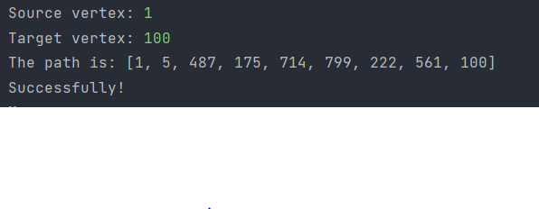

The output for the path from vertex 1 to vertex 100 in the graph10k.txt is:

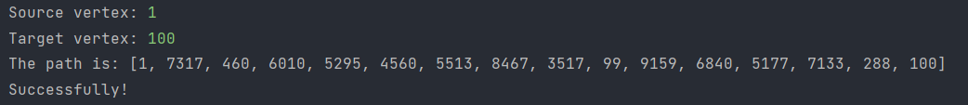

The output for the path from vertex 1 to vertex 100 in the graph100k.txt is:

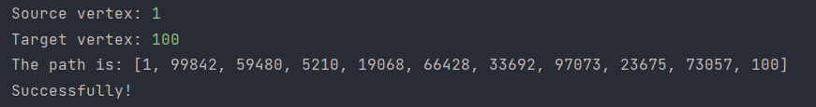

The output for the path from vertex 100 to vertex 1 in the graph1k.txt is:

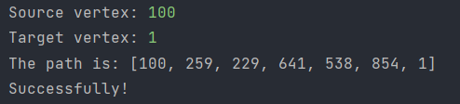

The output for the path from vertex 100 to vertex 1 in the graph10k.txt is:

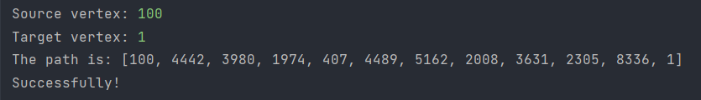

The output for the path from vertex 100 to vertex 1 in the graph100k.txt is:

